March 4th (Sunday)
We are mixing soil at Mike Betts house (1981 Cornell Road, Middleburg FL) starting at 10am. We will also have a shop and swap. So bring any items such as tools, plants, pots, etc. that you might want to sell or trade.

March 10th (Saturday)
One of my neighbors is looking to remove some azaleas from her yard. There are around a dozen azaleas that she is allowing our club to collect from her yard free of charge. They have been in her yard for 10+ years and would make a nice bonsai or landscape material.
For those who are interested we will collect the azaleas on Saturday March 10th 2018. We will meet at Josh’s house (12314 forest gate drive south, Jacksonville FL) at 10am. We have shovels, loppers, saws, and nursery containers. Each person will just need to bring some soil to plant their tree in and a little extra to help fill in the holes we dig. As with anything we collect, the goal will be to leave the area in as good as or better condition than when we found it.
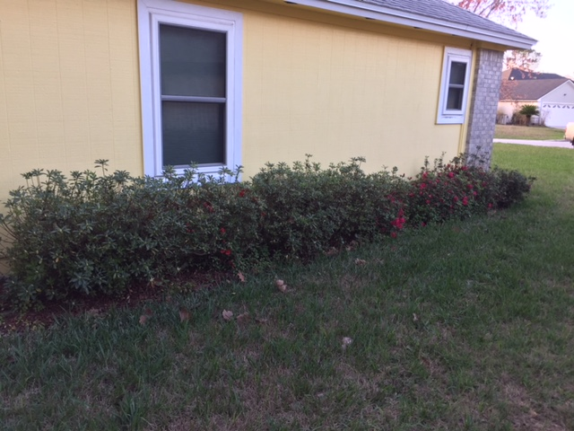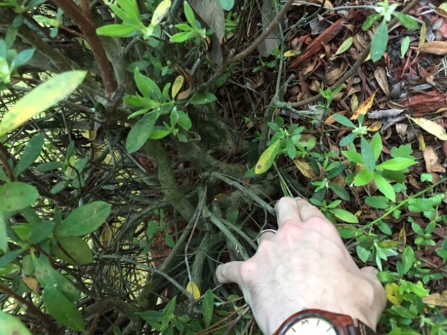
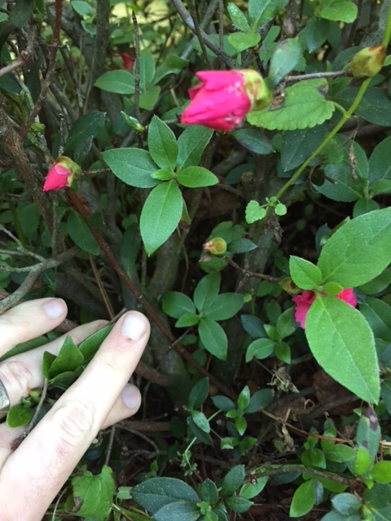
Regular meeting (March 12th) canceled for special event
SPECIAL EVENT March 15th - Workshop with BSF Visiting Artist Juan Andrade
- Bring any tree in your collection to work on. This is a good time to work on almost any species!!
- Start time is 7pm
- Location TBD
- Cost for participants is $30 and observer’s are free

The Japanese Maple event originally scheduled for March will be postponed until our April meeting.

